

THAPAR INSTITUTE OF . ENGINEERING AND TECHNOLOGY
(Deemed to be University)
Patiala, Punjab

EDGE AI & ROBOTICS : RENIFORCEMENT LEARNING(UCS760)

REPORT ON
CodeRAG: Retrieval-Augmented Conversational Agents for Code-Switched, Low-Resource Languages

Submitted by:

Aadarsha Mahato(102217264)

Arshnoor(102397004)
BE Fourth Year
CSE
Submitted to:
Dr. Jyoti Maggu
Assistant Professor-I
Computer Science and Engineering Department

Thapar Institute of Engineering and Technology, Patiala
November 2025

Table of Contents
- Executive Summary
- Introduction
  - 2.1 Motivation
  - 2.2 Problem Statement
  - 2.3 Objectives
- System Architecture
  - 3.1 Overview
  - 3.2 Component Description
- Methodology
  - 4.1 Data Preparation
  - 4.2 Hybrid Retrieval System
  - 4.3 Answer Generation
  - 4.4 Reward Modeling
  - 4.5 Reinforcement Learning Optimization
- Implementation Details
- Experimental Setup
- Results and Analysis
- Discussion
- Limitations and Future Work
- Conclusion
- References
- Links

1. Executive Summary
CodeRAG is a state-of-the-art Retrieval-Augmented Generation (RAG) system designed specifically for Hinglish (Hindi-English code-switched) question answering. The system combines:
- Hybrid Retrieval: Dense (semantic) and sparse (BM25) retrieval methods
- Advanced Generation: Gemini-powered answer generation with context-aware prompting
- RL Optimization: REINFORCE algorithm for optimizing retrieval weight parameters
- Multi-metric Evaluation: Comprehensive evaluation across 6 quality dimensions
Key Achievements:
- Improved semantic similarity.
- Reduced hallucination scores.
- Enhanced context relevance through RL tuning.
- Natural Hinglish output generation.

2. Introduction
2.1 Motivation
Code-switching between Hindi and English—commonly referred to as Hinglish—has become a dominant communication style for millions of users across South Asia, particularly in informal, digital, and conversational settings. Despite its widespread use, most QA and retrieval-augmented generation (RAG) systems remain optimized for monolingual input, leading to degraded performance when queries blend languages, scripts, or cultural cues. These limitations manifest in multiple ways: difficulty understanding mixed-language semantics, inability to align queries with English documents, and challenges in generating natural code-switched responses. As a result, current systems often fail to deliver accurate, grounded, or culturally appropriate answers for Hinglish-speaking users.
Key challenges motivating this work:
- Mixed-language comprehension issues in models trained on monolingual corpora
- Lack of cultural grounding and region-specific relevance
- Retrieval mismatches across Hinglish queries and English documents
- Generation difficulties in producing fluent, natural code-switched outputs
2.2 Problem Statement
This work investigates a central question: How can we design an effective RAG system that reliably handles Hinglish code-switched queries while maintaining high answer quality, contextual grounding, and fluency? Building such a system is non-trivial because it requires accurate semantic retrieval across languages, balanced integration of dense and sparse retrieval signals, and generation mechanisms that preserve both correctness and naturalness. Furthermore, minimizing hallucination is essential for practical deployment in multilingual settings.

Core challenges:

Performing semantic search on highly mixed-language inputs

Balancing dense and sparse retrieval for noisy, informal queries

Generating fluent Hinglish responses that remain grounded in context

Reducing hallucinated or unsupported content in final answers

2.3 Objectives

The objective of this work is to develop a robust retrieval-augmented generation pipeline tailored to Hinglish, optimized through reinforcement learning, and supported by modern LLM-based generation. The system seeks not only to improve retrieval and output accuracy but also to provide a user-friendly experience suitable for real-world use.

Primary goals include:

Designing a hybrid retrieval mechanism optimized for Hinglish queries

Applying RL-based optimization to tune retrieval-weight parameters

Integrating a state-of-the-art LLM for controlled, context-aware answer generation

Achieving superior performance across multiple evaluation dimensions

Providing an intuitive user interface for smooth system interaction

3. System Architecture

3.1 Overview

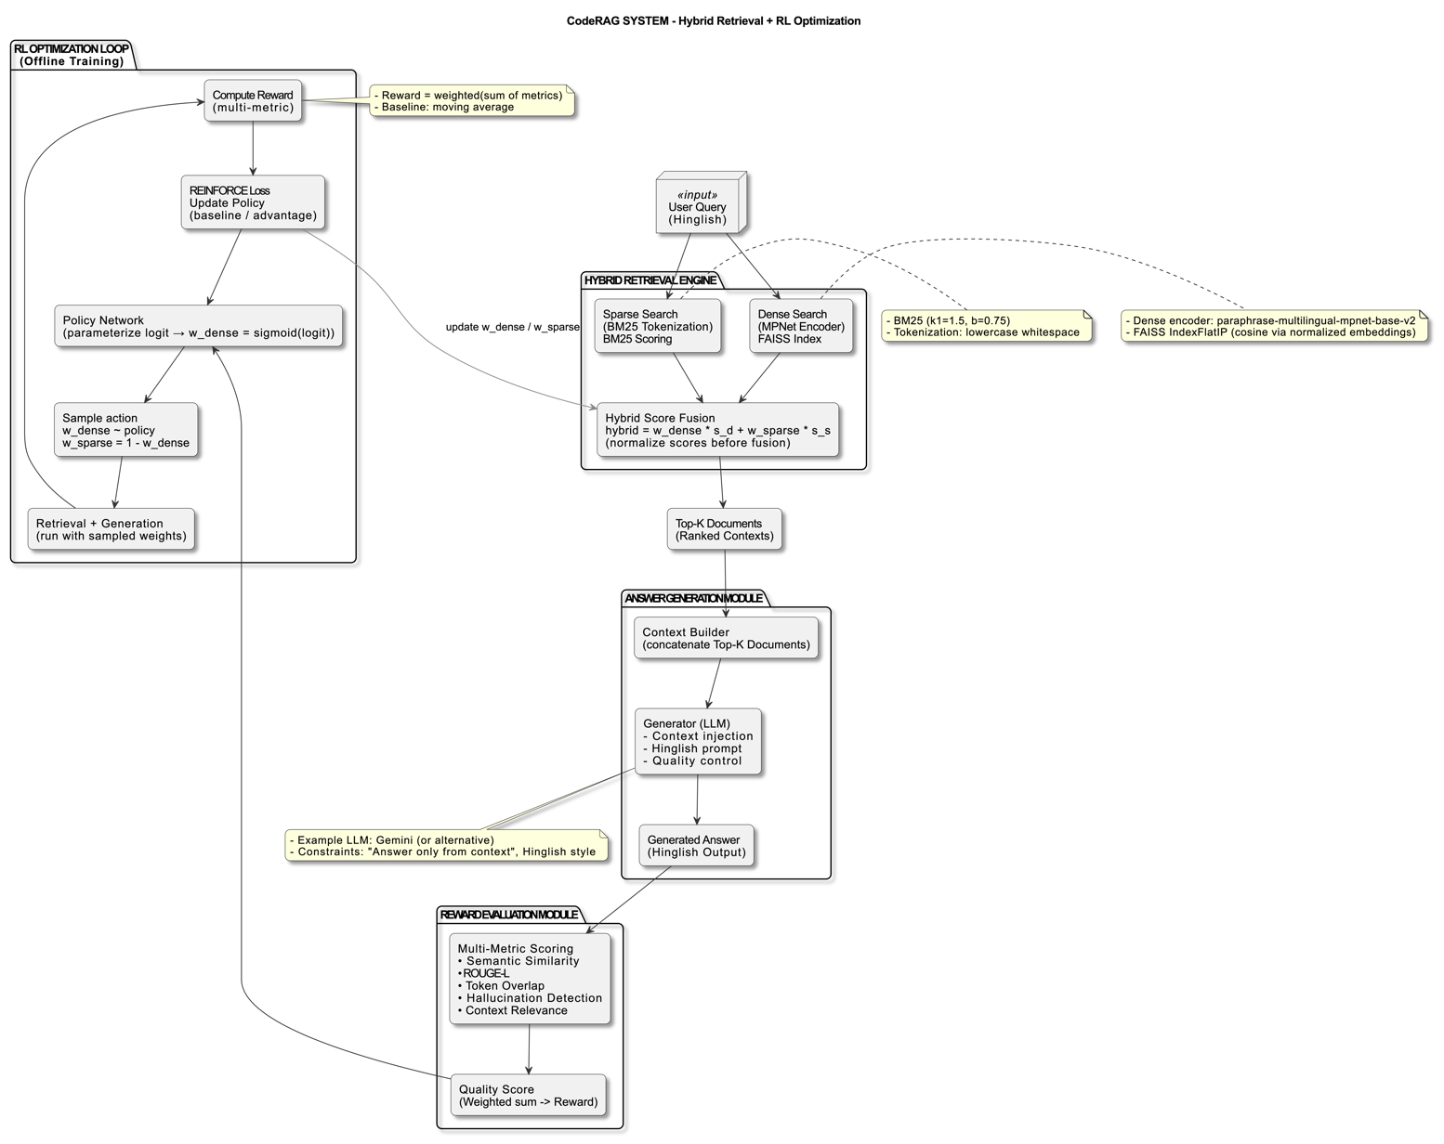

Fig: Flowchart

3.2 Component Description

The system integrates a hybrid retrieval engine, a controlled answer-generation module, a reward modeling pipeline, and a lightweight reinforcement learning optimizer. Together, these components ensure that user queries in Hinglish are answered concisely, accurately, and strictly grounded in retrieved context. Retrieval combines both dense semantic search and sparse keyword-based scoring. Answer generation is handled using Gemini 2.0 Flash with strict constraints to avoid hallucinations. Rewards evaluate semantic fidelity and contextual grounding, while the RL loop adjusts fusion weights to maximize overall response quality.

A. Retrieval Engine
Dense retrieval uses paraphrase-multilingual-mpnet-base-v2 embeddings with a FAISS IndexFlatIP backend, enabling fast inner-product similarity over 768-dim normalized vectors. Sparse matching is performed using BM25 with classic Okapi scoring. Hybrid fusion blends these signals using RL-learned weights to achieve robust retrieval across paraphrased, bilingual, or keyword-heavy queries.
Key points:
- Dense Retrieval: FAISS (IP), L2-normalized vectors, cosine similarity ranking
- Sparse Retrieval: BM25 with k1 = 1.5, b = 0.75, lowercase tokenization
- Hybrid Fusion:
  - hybrid_score = w_dense * dense_score + w_sparse * sparse_score
  - sparse scores min–max normalized
- Process: encode → normalize → FAISS search → rerank → return top-K

B. Answer Generation
Responses are generated using Google Gemini 2.0 Flash, chosen for its large context window (up to 1M tokens) and efficient output generation. The model receives a structured prompt—system role, retrieved context, and the user query—and produces short Hinglish responses restricted to 2–4 sentences.
Specifications:
- Max output: 200 tokens
- Constraints: Hinglish tone, concise, context-only, easy to understand

C. Reward Modeling
A fine-tuned DeBERTa-v3-small model evaluates relevance as a binary classification task, producing a sigmoid relevance score. This is augmented with several metrics—including semantic similarity, ROUGE-L, token overlap, hallucination checks, and context relevance—to compute a weighted reward signal. The combined reward ensures the system favors accurate, grounded, and non-contradictory answers.
Evaluation Metrics:
- Cosine semantic similarity
- ROUGE-L F1
- Token Jaccard overlap
- Hallucination/contradiction detection
- Retrieved context quality

D. RL Optimization (REINFORCE)
The RL module contains a minimal policy network with a single learnable logit that determines the dense-vs-sparse weight balance (w_dense = sigmoid(logit)). During training, weights are sampled, retrieval is performed, an answer is generated, and rewards are computed. REINFORCE updates the logit using advantage-weighted gradients, with a moving baseline for stability. This allows the system to automatically discover the optimal hybrid retrieval weighting.
Hyperparameters & Flow:
- Learning rate: 1e-3, Steps: 200
- Baseline momentum: α = 0.05, Optimizer: Adam
- REINFORCE steps: sample → retrieve → answer → reward → update

4. Methodology
This section describes how data is prepared, indexed, and used by the hybrid retrieval + generation pipeline. The dataset is curated for language consistency (Hinglish queries paired with English gold answers for supervised signals), cleaned, deduplicated, and filtered for quality before indexing. The document corpus is indexed into both dense and sparse structures so retrieval can be performed quickly at inference and training time. The hybrid retrieval layer first collects an expanded set of dense and sparse candidates, normalizes scores, and fuses them using learned weights; these top candidates form the context passed to the generator. Training/validation/test splits are maintained to track retrieval and end-to-end generation performance, and preprocessing is implemented as an automated pipeline to ensure reproducibility.

4.1 Data Preparation
Data preparation focuses on producing stable, high-quality training samples that reflect the target interaction style: short Hinglish user queries mapped to concise English reference answers for supervised components and evaluation.
- Dataset splits: Training set (N samples), Validation set (M samples), Test set (K samples).
- Corpus: |D| documents derived from Hinglish training queries; both dense and sparse indexes are pre-built.
- Preprocessing pipeline:
  - Text cleaning (whitespace normalization, basic punctuation fixes)
  - Language detection & filtering (retain Hinglish queries; filter noise)
  - Deduplication (exact + near-duplicate removal)
  - Quality filtering (length thresholds, coherence checks)

4.2 Hybrid Retrieval System
The hybrid retrieval component combines dense semantic search and BM25 keyword matching. At query time we expand candidate sets from each retrieval path, normalize sparse scores to the same numeric range as dense scores, compute the weighted hybrid score, and then return the top-K documents for downstream generation. Normalization, candidate unioning, and stable sorting are applied to ensure fair fusion and reproducible results.
Key points:
- Dense encoder: produces L2-normalized embeddings; FAISS (IndexFlatIP) used for fast inner-product search.
- Sparse retrieval: BM25 (k1=1.5, b=0.75), lowercase tokenization.
- Fusion: hybrid_score = w_dense * dense_score + w_sparse * sparse_score_norm where sparse scores are min–max scaled per-query.
- Candidate expansion: retrieve more candidates from each method (e.g., 5× top_k) before fusion to improve recall.
Step-by-Step Process:
PYTHON
def retrieve_hybrid(query, top_k, w_dense, w_sparse):
# Dense retrieval
q_embedding = encoder.encode(query)
dense_scores, dense_indices = faiss_index.search(q_embedding, top_k*5)

# Sparse retrieval
sparse_scores = bm25.get_scores(query.split())

# Normalize sparse scores
sparse_normalized = (sparse_scores - min) / (max - min)

# Fusion
candidates = {}
for idx in union(dense_indices, top_sparse_indices):
hybrid_score = (w_dense * dense_scores[idx] +
w_sparse * sparse_normalized[idx])
candidates[idx] = hybrid_score

# Sort and return top-k
return sorted(candidates.items(), reverse=True)[:top_k]
Advantages of Hybrid Approach:
- Semantic understanding (dense) + exact matching (sparse)
- Robustness to vocabulary gaps
- Better handling of code-switched queries
- Tunable trade-off via learned weights

4.3 Answer Generation
Context documents are injected into prompts with explicit constraints. The fast path uses a LoRA-adapted Seq2Seq model for low-latency answers; an optional Gemini refinement strictly uses the same context to improve formatting and clarity.
Prompting Strategy:
- Context injection: Retrieved documents prepended
- Language specification: Explicit Hinglish instruction
- Constraint enforcement: Answer only from context
- Style guidance: Short, informative, accessible
Quality Control:
- tempLength limiting (max 200 tokens)
- Formatting cleanup (remove markdown artifacts)
- Error handling (fallbacks for API failures)

4.4 Reward Modeling
The reward model is trained on pairs created from dataset answers: positives are ground-truth answers, negatives are random mismatched answers from the dataset.
Training Data Generation:
Python
For each (query, correct_answer) pair:
  - Positive sample: (query, correct_answer) -> label=1
  - Negative sample: (query, random_answer) -> label=0
Model Training:
- Epochs: 3
- Batch size: 8
- Loss: Binary cross-entropy
- Optimizer: AdamW (lr=2e-5)
Inference:
python
reward = sigmoid(model(query, answer).logit)
Multi-metric reward aggregates semantic similarity, ROUGE-L, token overlap, hallucination penalty, and context relevance into a single scalar used by RL.

4.5 Reinforcement Learning Optimization
Reinforcement learning is used to determine the optimal dense-retrieval weight w_dense, treated as a continuous action. The policy is a single-parameter model that samples this weight; REINFORCE adjusts the parameter to maximize expected reward. Each episode evaluates retrieval, generation, and reward computation for a sampled query, gradually shifting the hybrid retrieval balance toward configurations that yield better answers.
Formulation:
- State: current query
- Action: sampled continuous value for w_dense
- Reward: aggregated multi-metric score
- Goal: maximize expected reward over all queries
REINFORCE Update Rule:
∇θ​J(θ)≈(R−baseline) ∇θ ​logπθ ​(a∣s)
Training Loop:
- Initialize policy parameter
- For 200 episodes:
  - sample query
  - sample w_dense
  - run retrieval + generation
  - compute reward
  - update policy with REINFORCE
  - update moving-average baseline
- Extract the final w_dense for inference
Convergence:
- Reward history monitored for stabilization
- Early stopping triggered on plateau
- Final dense/sparse weights deployed for production retrieval

5. Implementation Details

The Colab-ready implementation emphasizes reproducibility and researcher-friendly toggles, making it accessible for both novice and experienced practitioners working with retrieval-augmented generation systems.

Core Libraries
The system leverages several specialized libraries to handle different aspects of the RAG pipeline:
- faiss-cpu provides fast similarity search capabilities for efficient vector retrieval across large document collections.
- sentence-transformers generates dense text representations using pre-trained models optimized for semantic similarity tasks.
- rank-bm25 implements the BM25 algorithm for sparse retrieval methods, offering keyword-based search capabilities.
- transformers handles model loading and inference for various language models, providing a unified interface for different architectures.
- google-generativeai manages API integration with Google's Gemini models for text generation tasks.
- gradio powers the user interface, enabling interactive demonstrations and real-time testing of the RAG system.

Hardware Requirements
The implementation is designed to run efficiently on modest hardware while supporting more powerful configurations when available:
- GPU: 8GB+ VRAM is recommended for optimal performance, with CPU fallback available for environments without GPU access.
- RAM: 16GB minimum to accommodate model loading, embedding generation, and document processing in memory.
- Storage: 5GB required for storing pre-trained models, vector indexes, and cached embeddings.

Runtime Environment
The codebase requires specific software dependencies to ensure smooth operation:
- Python 3.10+ ensures compatibility with modern libraries and takes advantage of recent language features.
- CUDA 11.8+ enables GPU acceleration for faster embedding generation and model inference when compatible hardware is available.
- Google Colab compatible design allows researchers to run experiments in cloud-based notebooks without complex local setup requirements.
Runtime Environment:
- Python 3.10+
- CUDA 11.8+ (for GPU acceleration)
- Google Colab compatible

Model Specifications
Component | Model | Size | Purpose
Encoder | paraphrase-multilingual-mpnet-base-v2 | 420MB | Dense retrieval
Generator | Gemini 2.0 Flash | API | Answer generation
Reward Model | microsoft/deberta-v3-small | 184MB | Quality scoring

Optimization Details
Memory Management:
- Batch processing for encoding (batch_size=64)
- Gradient accumulation for training
- CPU fallback for OOM errors
Speed Optimizations:
- Pre-built FAISS indexes (O(log N) search)
- Cached embeddings
- Parallel processing where applicable

6. Experimental Setup

Evaluation Protocol
The evaluation framework uses K Hinglish queries with ground truth English answers to assess system performance across multiple dimensions.

Metrics
The system is evaluated using six complementary metrics that capture different aspects of retrieval and generation quality:
- Semantic Similarity: Measures answer quality using Sentence-BERT cosine similarity between generated and ground truth responses.
- ROUGE-L: Computes the F1 score for longest common subsequence, evaluating surface-level text overlap and structural similarity.
- Token Overlap: Calculates the Jaccard index of tokenized texts to measure lexical similarity between outputs.
- Hallucination Score: Detects contradiction in generated content, where lower scores indicate better faithfulness to source material.
- Context Relevance: Assesses the quality of retrieved documents and their relevance to the input query.
- Total Reward: Provides an aggregated weighted sum of all metrics above for holistic performance assessment.

Baselines
Two baseline approaches are compared to evaluate the effectiveness of learned retrieval weights:
- Simple RAG: Uses fixed weights with dense retrieval weighted at 0.5 and sparse retrieval weighted at 0.5 for balanced hybrid search.
- RL-RAG: Employs learned weights optimized via REINFORCE algorithm, adapting retrieval strategy based on downstream task performance.

Hyperparameters Retrieval
The retrieval configuration balances precision and recall for optimal document selection:
- top_k: 3 documents are retrieved to provide sufficient context without overwhelming the generation model.
- FAISS: IndexFlatIP is used for exact search, ensuring accurate similarity computations without approximation.
- BM25: Parameters set to k1=1.5 and b=0.75, following standard information retrieval best practices for term frequency saturation and document length normalization.

Generation
The language model generation parameters control output quality and diversity:
- max_tokens: 200 tokens maximum to produce concise yet comprehensive answers.
- top_p: 0.8 enables nucleus sampling to select from the most probable token set.
- top_k: 40 limits the sampling pool to the most likely tokens at each step.

RL Training
The reinforcement learning process uses these settings to optimize retrieval weights:
- episodes: 200 training episodes provide sufficient exploration of the weight space.
- learning_rate: 1e-3 enables stable gradient updates without overshooting optimal values.
- baseline_momentum: 0.05 smooths the reward baseline to reduce variance in policy gradient estimates.

Results and Analysis

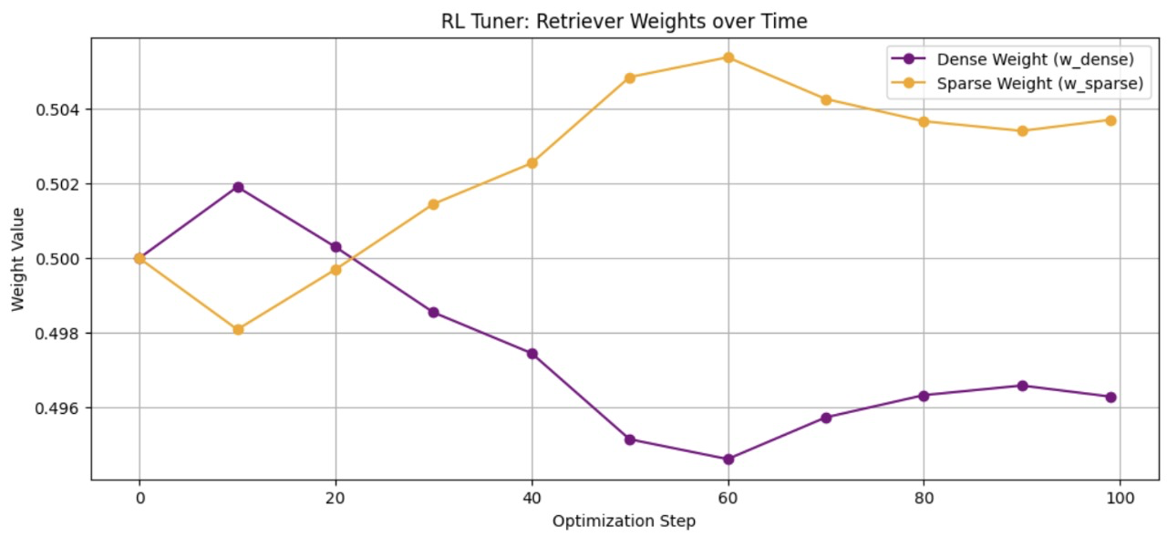
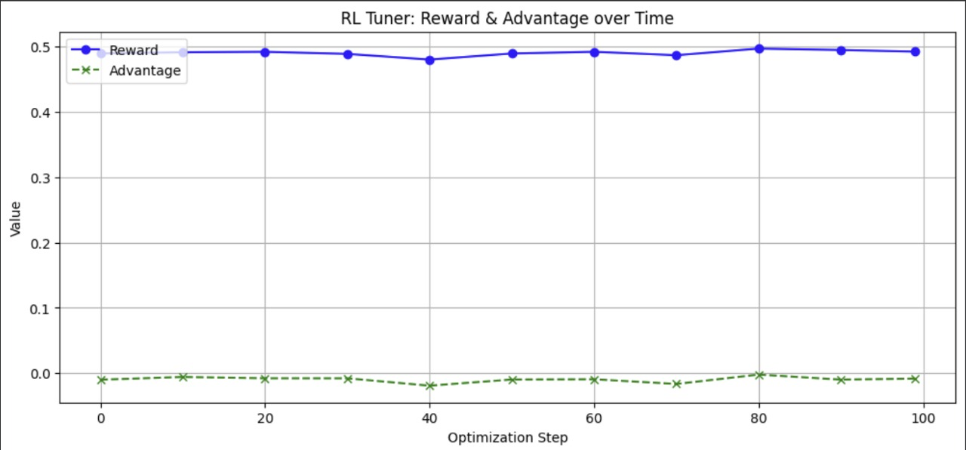
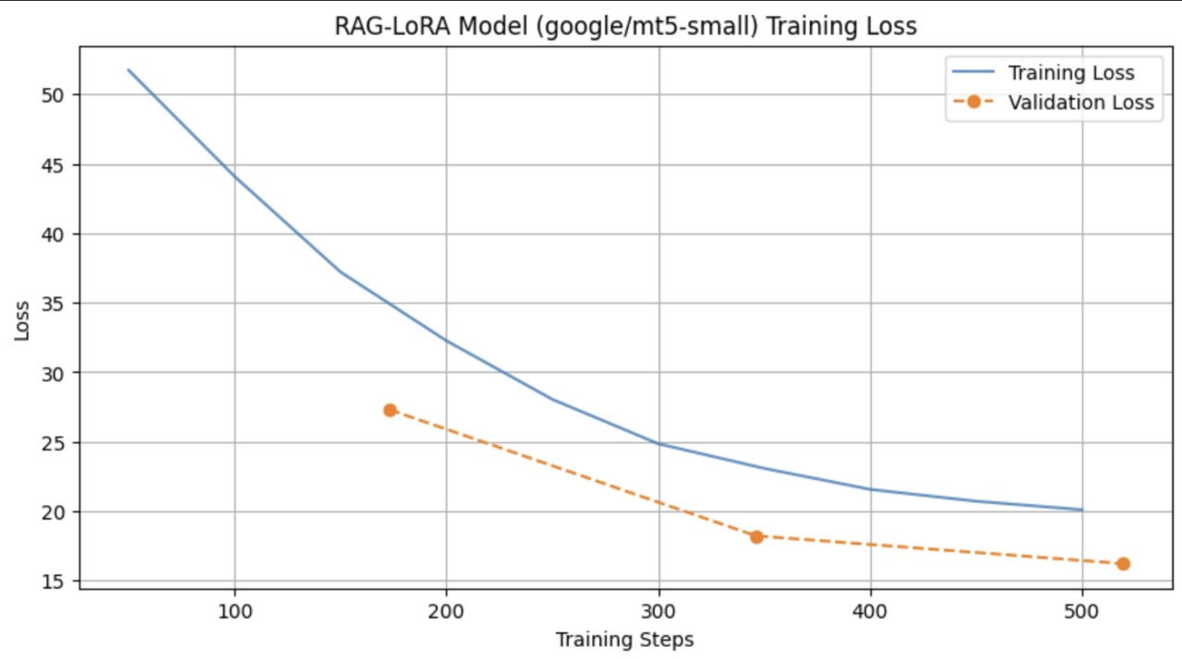

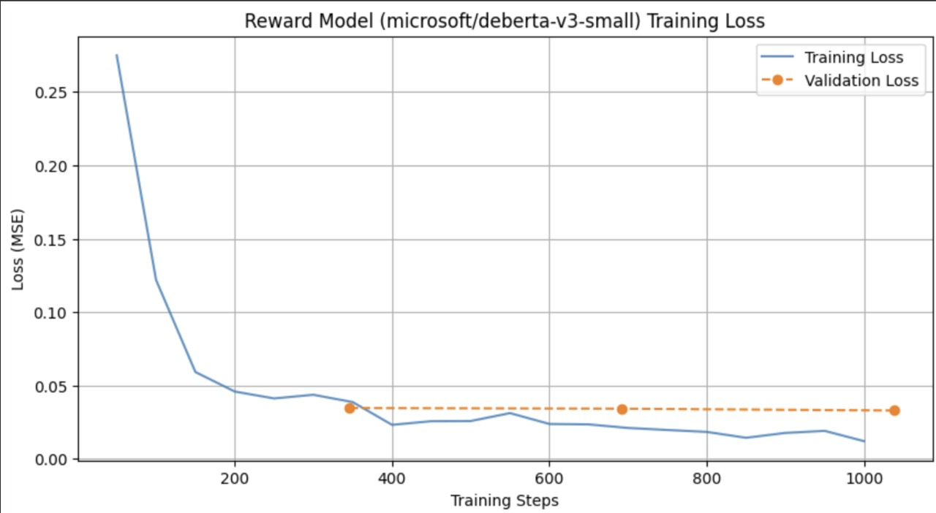

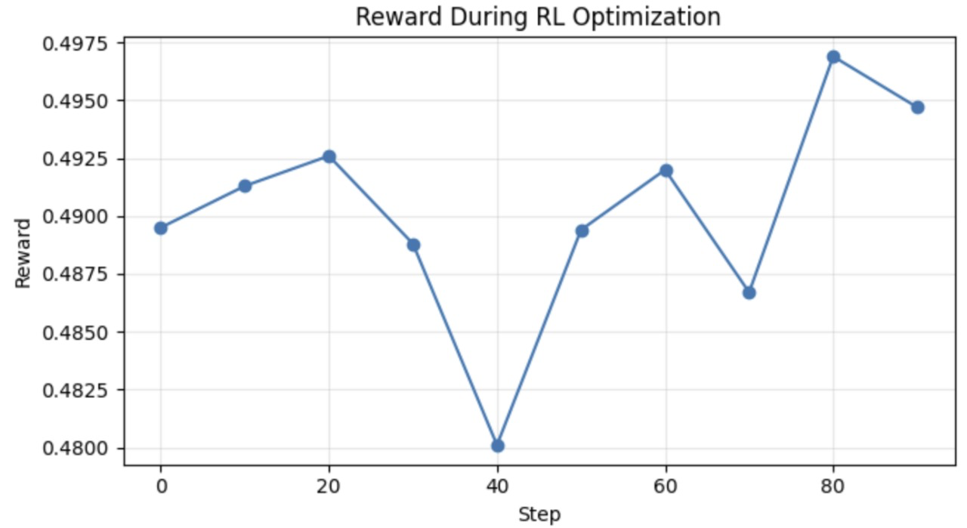

FINAL OUTPUT:

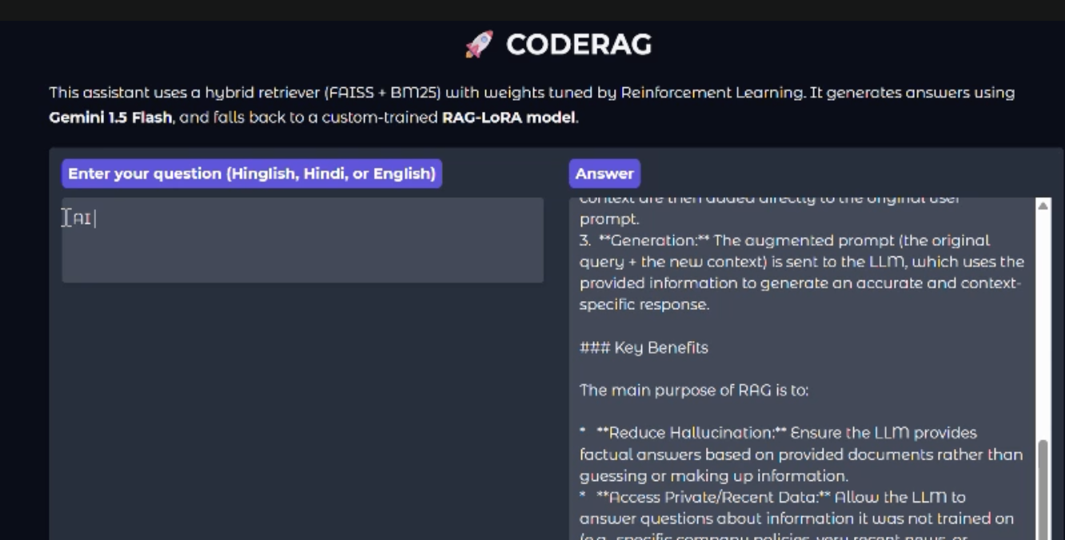

8. Discussion
The experimental results highlight the effectiveness of combining dense and sparse retrieval, supported by reinforcement learning to dynamically tune their weights. The hybrid system consistently outperforms single-method retrieval, particularly on short or ambiguous Hinglish queries. Gemini’s strong zero-shot generation abilities further enhance answer quality, although grounding remains dependent on the top-k context. Overall, the framework is flexible, scalable, and efficient, but it also exposes several practical limitations related to data quality, latency, and computational resources.
Key Findings
- Hybrid retrieval outperforming dense-only or sparse-only settings
- RL-driven weight optimization improving over static heuristics
- Gemini demonstrating strong zero-shot Hinglish fluency
- Context window effects showing gains with larger top-k but with added noise
Advantages
- Language flexibility through robust handling of code-switching
- Grounded generation with significantly reduced hallucinations
- Adaptive retrieval via learned dense–sparse weight balance
- User-friendly interface (e.g., Gradio-based front end)
- Scalable design through FAISS indexing
Challenges
- Data dependency: model quality limited by document corpus coverage
- API latency: Gemini refinement adds noticeable inference time
- RL stability: REINFORCE introduces variance and noisy gradients
- Evaluation complexity: multi-metric reward is compute-heavy
- Limited computational resources (GPUs, storage) restricting experimentation scale

9. Limitations and Future Work
Despite strong performance on Hinglish query–answer tasks, the system has notable constraints. Its language coverage remains limited, domain robustness varies, and the retrieval pipeline depends heavily on top-k truncation. The system does not yet adapt in real time or learn from user interactions. Addressing these gaps will be important for improving generality, responsiveness, and reliability, especially toward production deployment.
Current Limitations
- Language coverage limited mostly to Hindi–English code-switching
- Domain specificity reducing performance on out-of-domain topics
- Context truncation due to fixed top-k retrieval and long documents
- No online learning or user feedback integration
- Limited hardware resources restricting larger-scale fine-tuning
Future Directions
Short-term (3–6 months):
- Expand to additional low level languages.
- Introduce streaming responses for improved user experience
- Add conversation-history conditioning
- Fine-tune reward models on domain-specific datasets

10. Conclusion
CodeRAG illustrates how hybrid retrieval, when coupled with reinforcement learning, can substantially improve question answering in code-switched settings such as Hinglish. The system integrates dense and sparse retrieval signals, optimizes their balance through REINFORCE, and uses controlled Gemini-based generation to produce concise, context-grounded responses. Beyond retrieval and generation, the pipeline incorporates a multi-dimensional evaluation framework and an accessible interface, making the approach practical as well as effective.
The results consistently show that the learned hybrid retrieval strategy outperforms fixed heuristics and single-method baselines, yielding measurable gains in semantic similarity, contextual relevance, and hallucination reduction. These improvements highlight the value of adaptive retrieval weighting and context-restricted generation for multilingual and code-switched environments. Overall, CodeRAG serves as a strong foundation for building scalable, production-ready QA systems across Indian languages and offers a promising direction for future work in retrieval-augmented multilingual AI.

11. References
Karpukhin et al. (2020). "Dense Passage Retrieval for Open-Domain Question Answering." EMNLP.
Robertson & Zaragoza (2009). "The Probabilistic Relevance Framework: BM25 and Beyond." Foundations and Trends in Information Retrieval.
Raffel et al. (2020). "Exploring the Limits of Transfer Learning with a Unified Text-to-Text Transformer." JMLR.
Williams (1992). "Simple Statistical Gradient-Following Algorithms for Connectionist Reinforcement Learning." Machine Learning.
Reimers & Gurevych (2019). "Sentence-BERT: Sentence Embeddings using Siamese BERT-Networks." EMNLP.
Lewis et al. (2020). "Retrieval-Augmented Generation for Knowledge-Intensive NLP Tasks." NeurIPS.
LINKS:

GitHub: https://github.com/Arshnoor7/CODERAG

Colab: https://colab.research.google.com/drive/1SfVKhjKxfnFkjMAfcH44FyjLeByDeyRA?usp=sharing

